E-Commerce Simulation with Dynamic Discount Rule Engine
Student Name: Muhammad Ayaz
Roll Number: 62795
Date: 3/12/25

Introduction
This project simulates an e-commerce platform. The platform allows users to browse products, add them to a cart, apply discounts, and checkout. The system includes product catalog management, inventory management, bundles and combos, price-drop notifications, wish list, search, and category filtering. The goal of this project is to demonstrate the use of design patterns in software construction and design while building a functional web application.

Design Pattern Usage

Factory Method
- Problem it solves
The factory method simplifies the creation of products for different categories.
- Implementation
Product Factory is used to create products. Electronics Factory and Clothing Factory extend it to create category-specific products.
- Classes
ProductFactory is the base class. ElectronicsFactory and ClothingFactory are subclasses.

Abstract Factory
- Problem it solves
Organize families of products such as Electronics, Clothing, and Home Appliances.
- Implementation
ElectronicsFactory, ClothingFactory, and HomeAppliancesFactory create products of their respective categories.

Builder Pattern
- Problem it solves
Assemble complex cart objects step by step.
- Implementation
CartBuilder is used to create a cart object in a structured way.

Decorator Pattern
- Problem it solves
Apply discounts dynamically without changing the cart class.
- Implementation
PercentageDiscount and FlatDiscount decorate CartTotal to calculate discounted prices.

Singleton Pattern
- Problem it solves
Ensure there is only one instance of the inventory for the entire system.
- Implementation
InventorySingleton ensures a single inventory instance is shared across the application.

Facade Pattern
- Problem it solves
Simplify the checkout process by combining cart and discount logic.
- Implementation
CheckoutFacade manages the checkout workflow including discounts and final total calculation.

Implementation Details
- Languages used
Python for backend and HTML, CSS, JavaScript for frontend
- Frameworks and Libraries
Flask framework for backend, standard JavaScript for frontend interaction
- Folder Structure
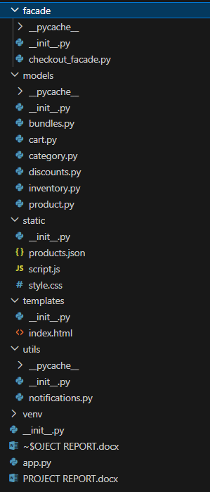

Screenshots and Output

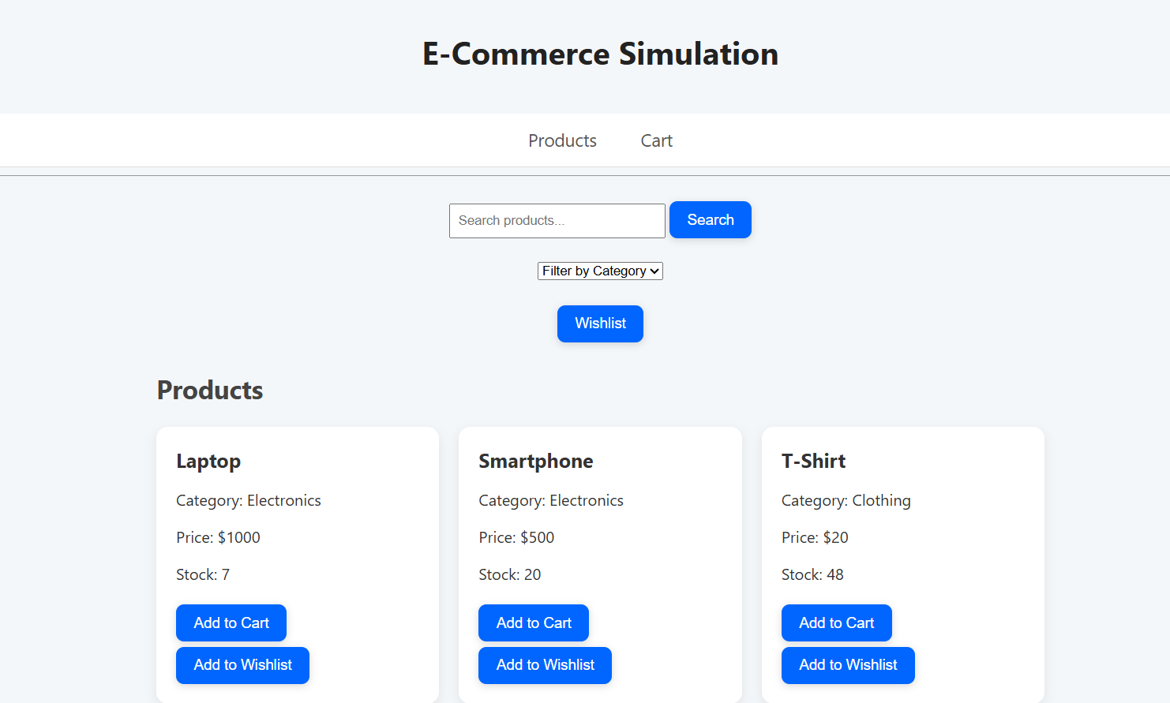

Here I added a laptop to cart

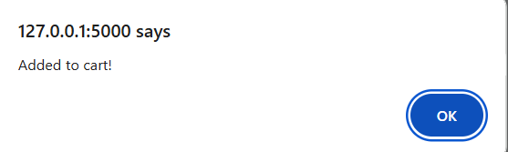

Before it was 7 and after 6
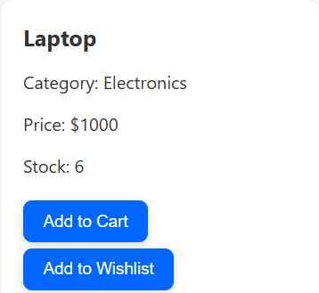

We can checkout if we want or can clear as well

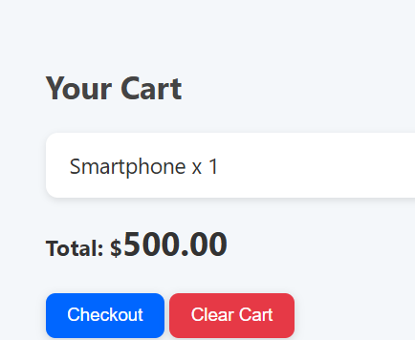

We Can get discount as well

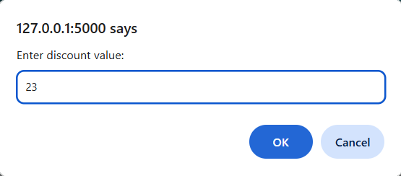

If something we like we can add to wishlist and later review

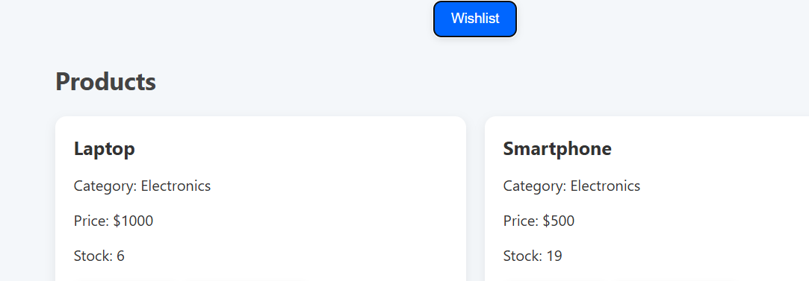

How to Run the System
- Make sure Python 3 is installed.
- Open the project folder in your terminal.
- (Optional) Create a virtual environment pastet: python -m venv venv
- Activate the virtual environment:
- For Windows PowerShell: venv\Scripts\Activate.ps1
(If blocked, use Set-ExecutionPolicy -Scope Process -ExecutionPolicy Bypass first)
- Windows CMD or vs code: venv\Scripts\activate.bat
- Linux / Mac: source venv/bin/activate
- Install required libraries:
pip install flask
- Run the application:
python app.py
- Open your browser and go to:
http://127.0.0.1:5000 hold control and click on the lick or directly open with double click on index file

keep in mind that app.py must pe running before opening

Dependencies
- Python 3.x
- Flask

Conclusion
The project demonstrates the practical use of design patterns such as Factory, Abstract Factory, Builder, Decorator, Singleton, and Facade. All functionalities including product catalog, cart management, discounts, bundles, wishlist, search, and filters are fully implemented and tested. The system is ready for demonstration.

